1. **Uml Diagram for Library Management System**

**Aim:** To draw the UML diagram for library management system using Umbrello tool.

**Use case diagram:**

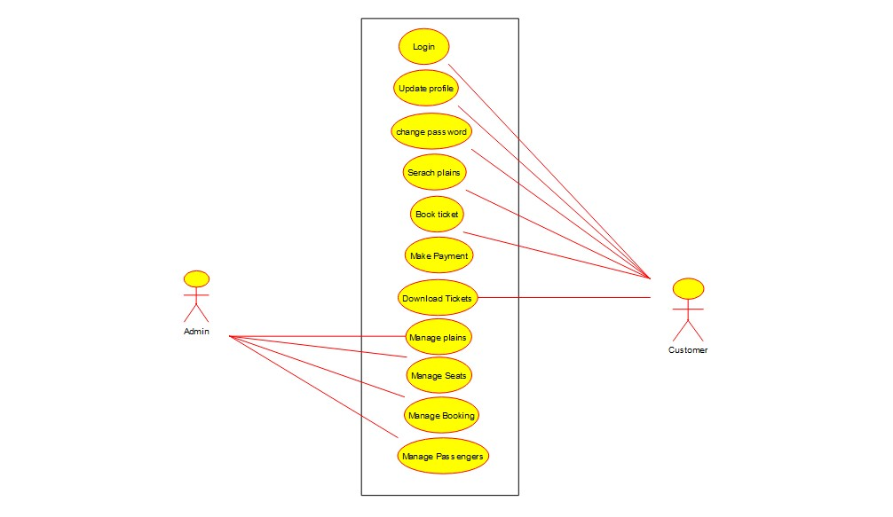

**Class diagram:**

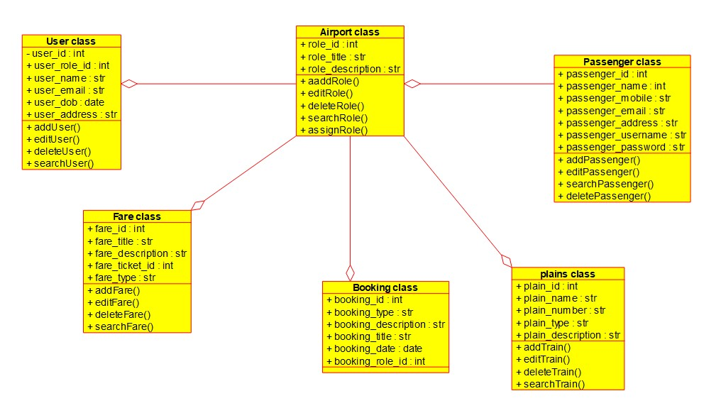

**Sequence diagram:**

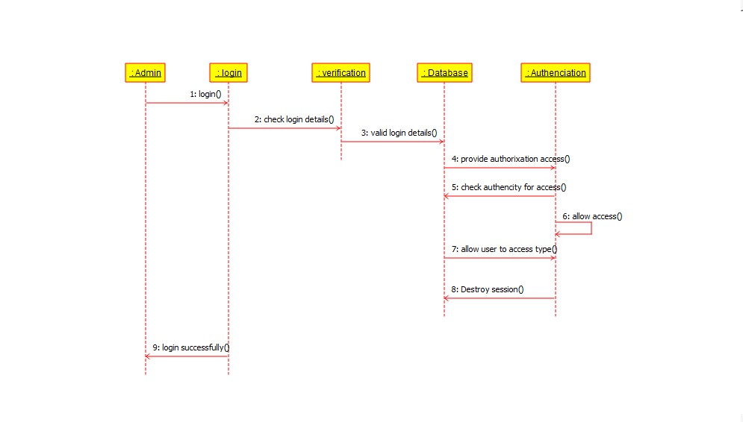

**Activity diagram:**

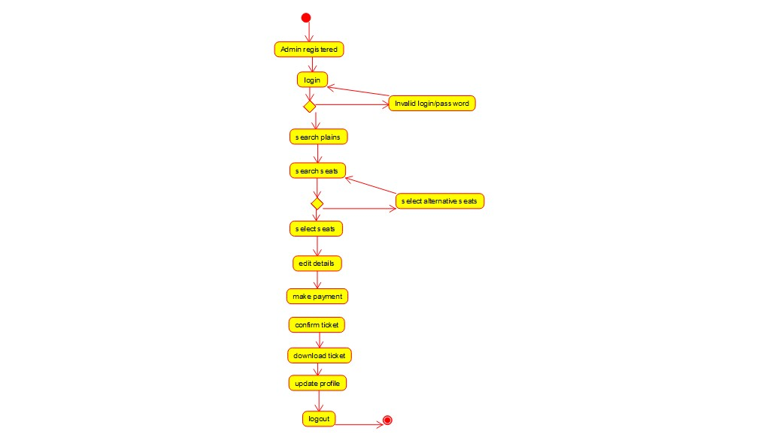

**Result: Hence, the library management system drawn successfully.**